**ST.XAVIER,S COLLEGE**

**Maitighar, Kathmandu**



Digital Logic Lab Assignment #4

**To implement BLA line drawing algorithm.**

Yub Raj Basnet

013BScCSIT048 (4th Semester)

**Submitted to**

|  |  |
| --- | --- |
| Er. Anil Sah  (Lecturer, St.Xavier’s College ) |  |

**Submitted date: Aug 18, 2015**

# STATEMENT

To implement the DDA line drawing algorithm:

# ALGORITHM:

* Input the two line endpoints and the left endpoint at (x0,y0)
* Load (x0,y0) into frame buffer, i.e. plot the first point.
* Calculate constants 2∆x, 2∆y and obtain first decision parameter p0 = 2∆y – ∆x
* At each xk along the line, starting at k = 0, perform the following test,
  + If pk < 0, next point is (xk+1,yk) and pk+1 = pk + 2∆y
  + Otherwise, next point to plot is (xk+1,yk+1) and pk+1 = pk + 2∆y – 2∆x
* Repeat step 4 ∆x times.

**Source Code**

//---------------------------------------------------------------------------

#include <vcl\vcl.h>

#pragma hdrstop

#include "Unit1.h"

//---------------------------------------------------------------------------

#pragma resource "*.dfm"

TForm1 *Form1;

//---------------------------------------------------------------------------

__fastcall TForm1::TForm1(TComponent* Owner)

: TForm(Owner)

{

}

//---------------------------------------------------------------------------

void __fastcall TForm1::Button1Click(TObject *Sender)

{

int x1,y1,x2,y2;

x1=StrToInt(Edit1->Text);

y1=StrToInt(Edit2->Text);

x2=StrToInt(Edit3->Text);

y2=StrToInt(Edit4->Text);

int x, y, dx, dy, pk, k, xEnd;

dx=abs(x2-x1);

dy=abs(y2-y1);

if(x1>x2)

{

x = x2;

y = y2;

xEnd = x1;

}

else

{

x = x1;

y = y1;

xEnd = x2;

}

Image1->Canvas->Pixels[x][y]=RGB(0,0,255);

pk=2*dy-dx;

while (x<=xEnd)

{

if(pk<0)

{

x=x+1;

y=y;

pk=pk+2*dy;

}

else

{

x=x+1;

y=y+1;

pk= pk+2*dy-2*dx;

}

Image1->Canvas->Pixels[x][y]=RGB(0,0,255);

}

}

//---------------------------------------------------------------------------

# Output

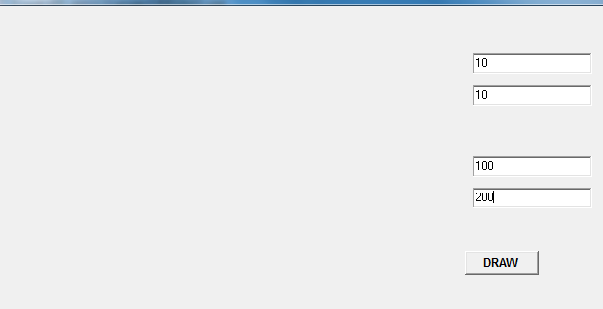

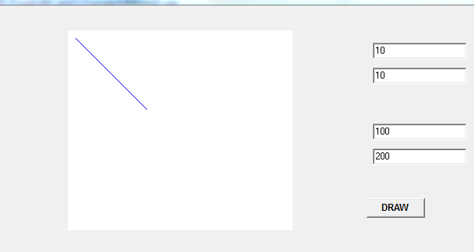

# Conclusion:

Hence, the BLA algorithm was implemented using C++ builder.

# Reference

https://users.soe.ucsc.edu/~pang/160/f12/slides/bla.pdf